**AMERICAN ACADEMY LARNACA**

**PLACEMENT EXAM**

**Year 4**

Sample 1

Time: 2 hours

|  |  |
| --- | --- |
| **Materials required for examination** | **Items included with question papers** |
| Nil | Nil |
|
| **Calculators may be used in this examination.** | |

**Information for Candidates**

Full marks may be obtained for answers to ALL questions.

This paper has 24 questions.

**Advice to Candidates**

You must ensure that your answers to parts of questions are clearly labelled.

You must show sufficient working to make your methods clear to the examiner.

Answers without working may gain no credit.

**Question 1**



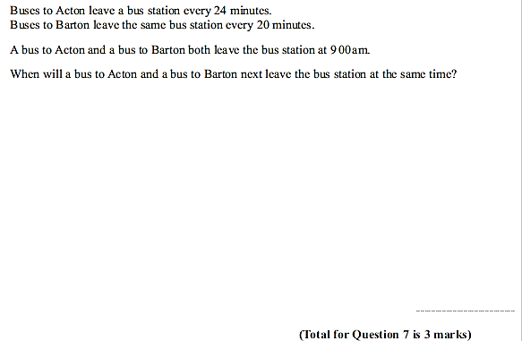

……………..**[2]**

**Question 2:**

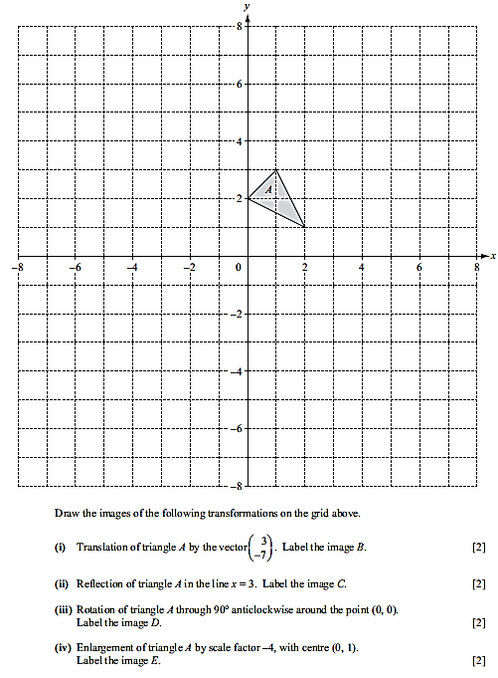

**Question 3:**

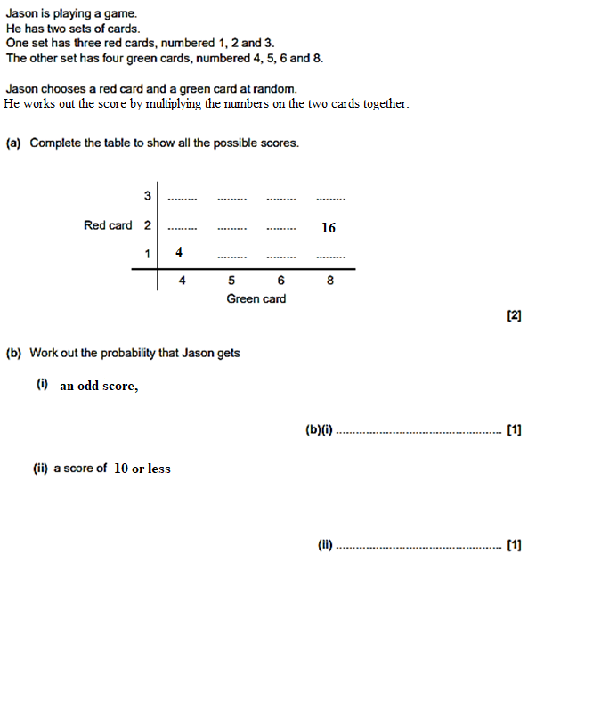

**Question 4:**

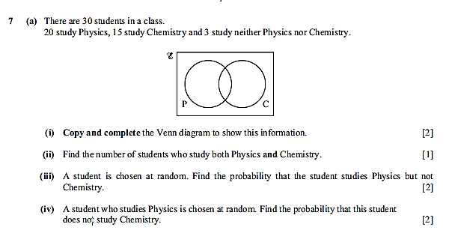

**Question 5:**

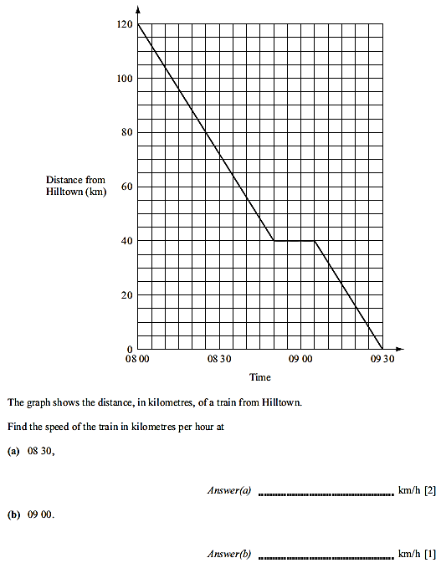

**Question 6:**

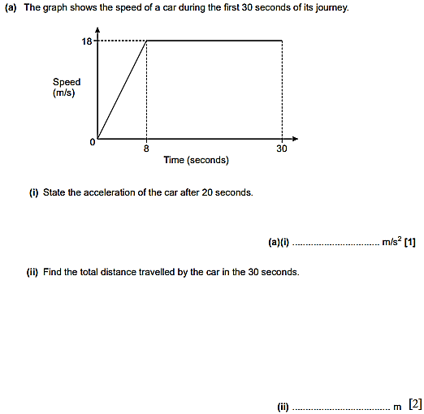

**Question 7:**



When *d* = 4, *F* = 30.

1. Find a formula for *F* in terms of *d*.

*F* = …………..  
**(3)**

1. Calculate *d* when *F* = 7.5.

*d* = …………..  
**(2)**

**Question 8:**

Write $356 000$ in standard for,

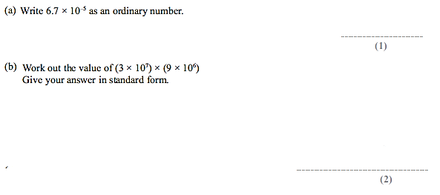

$$(2.5×{10}^{5})÷(5×{10}^{8})$$

**Question 9:**

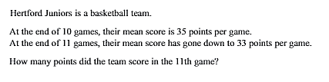

…………….  
**(3)**

**Question 10:**

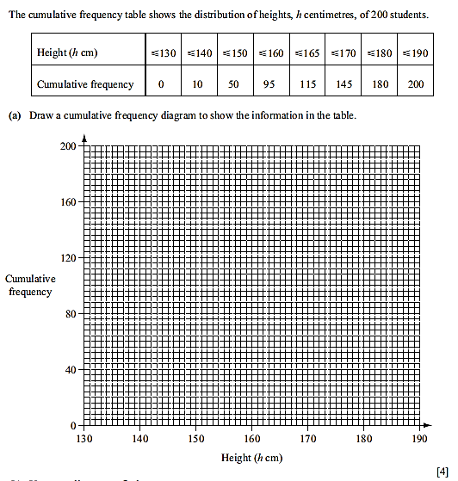

Use the graph to find:

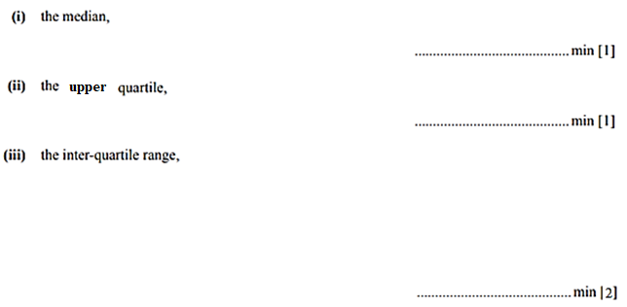

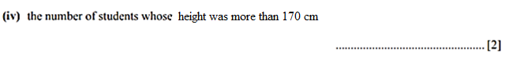

b) The frequency table shown below shows the heights of the 200 students.

|  |  |  |
| --- | --- | --- |
| **Height (*h cm*)** | **Frequency** |  |
| $$130 <h ≤140$$ | 10 |  |
| $$140 <h ≤150$$ | 40 |  |
| $$150 <h ≤160$$ | 45 |  |
| $$160 <h ≤165$$ | 20 |  |
| $$165 <h ≤170$$ | 30 |  |
| $$170 <h ≤180$$ | 35 |  |
| $$180 <h ≤190$$ | 20 |  |

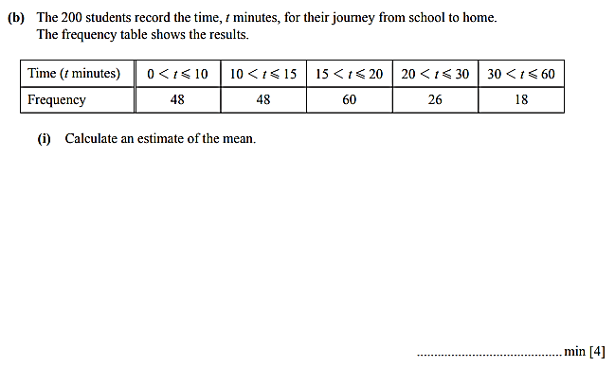

………………………………..minutes **[3]**

**Question 11:**   
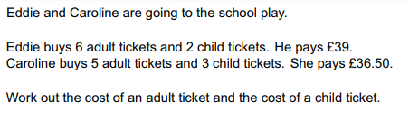



**(4)**

**Question 12:**

$$9x^{2}-25$$

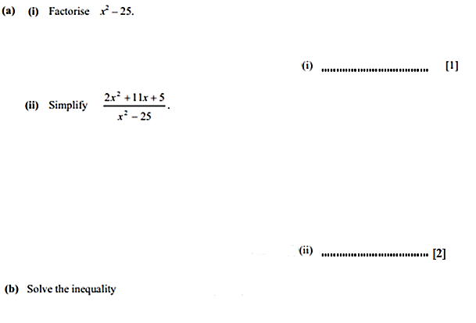

$$\frac{3x^{2}+4x-5}{{9x}^{2}-25}$$

b) List the integer solutions of $$6-x<4-2x ≤28+2x$$

……………………….**(3)**

**Question 13:**

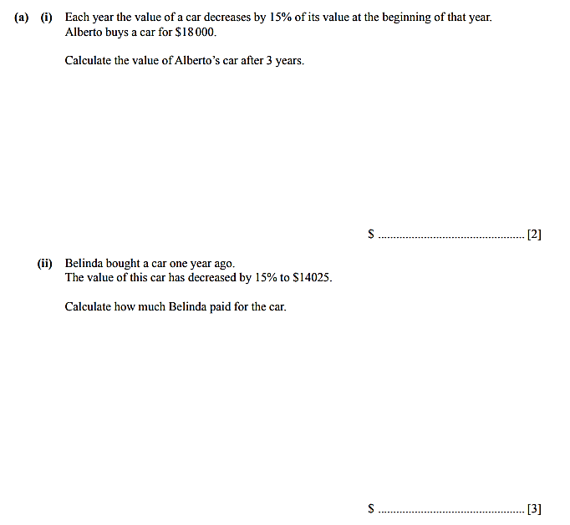



b) Nick invests €12 300 in the bank, at compound interest 4% p.a.  
 After how many years will Chris have more than €17 000 in his account?  
 Show all your working.

**........................(2)**

**Question 14:**

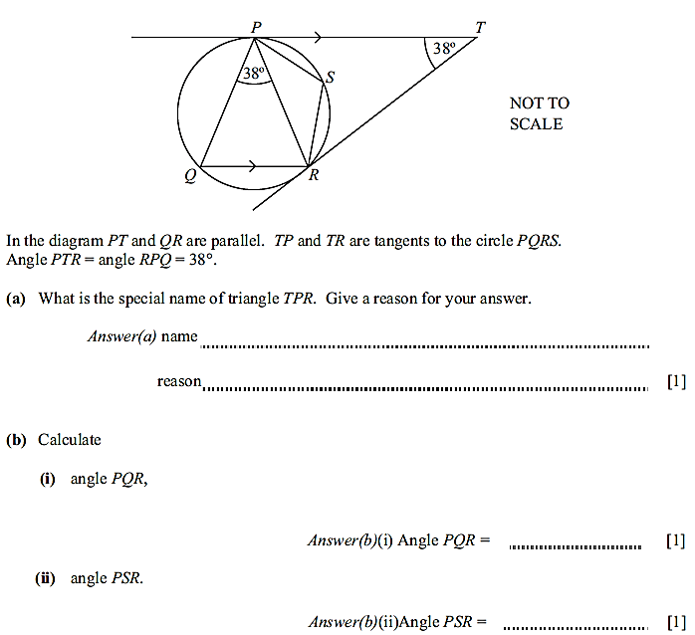

**Question 15:**

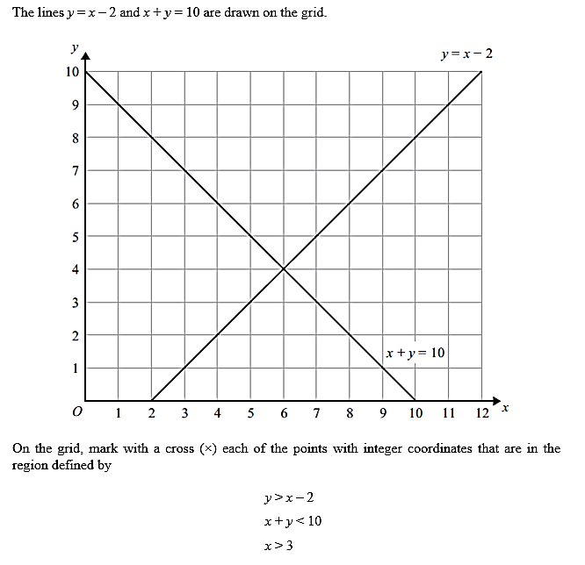

**(3)**

**Question 16:**

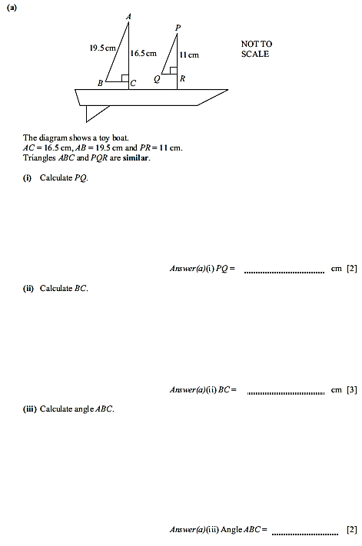

**Question 17:**

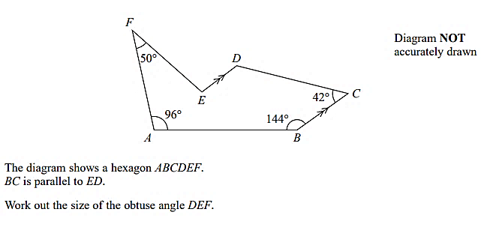

……………….

**(3)**

**Question 18:**

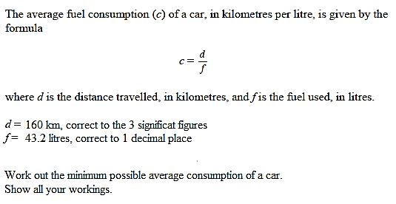

………………

**(3)**

**Question 19:**

**(a)** Rearrange the formula to make ***d*** the subject of the formula.

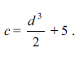

*d =*………………….**(3)**

**(b)** Rearrange the formula to make ***x*** the subject of the formula.



*x*=……………………

**(3)**

**Question 20:**

**(a)** Evaluate the following WITHOUT using a calculator. Show ALL your workings.



(i)  ……………

1. 

……………

1. ${\left(-\frac{3}{5}\right)}^{-2}$……………

**(4)**

1. Simplify fully

**(i)**  ……………

**(ii) ${\left(81a^{6}b^{3}\right)}^{\frac{1}{2}}$**

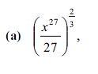…………… **(3)**

**c) (i)**

****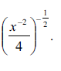**   
  
  
  
  
  
 (ii)**

**Question 21:**



1. 





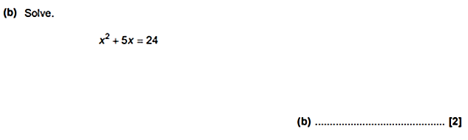

**Question 22:**

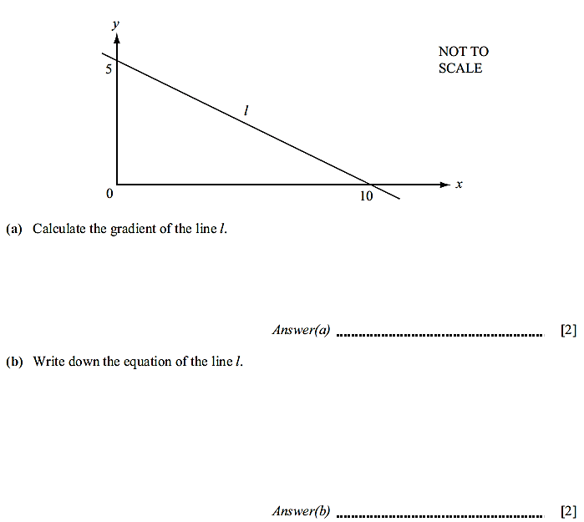

1. Work out the equation of the line which is parallel to line l, and passes through the point (4. -3)

…………………**(3)**

**Question 23:**

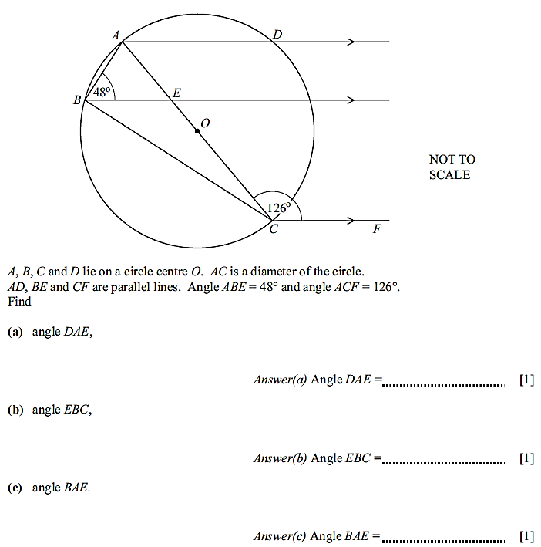

**Question 24:**

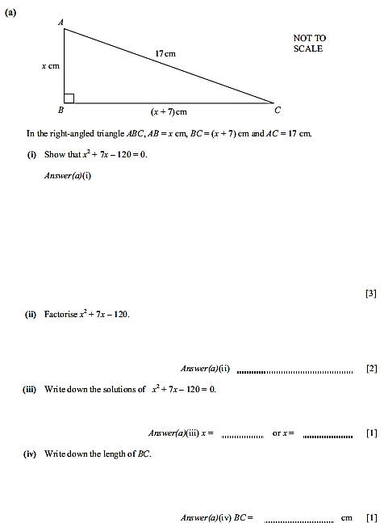

**THE END!!**